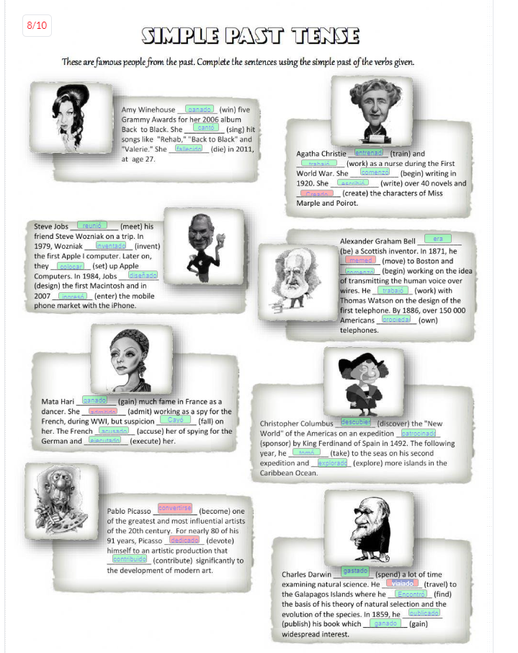

This morning I woke up at 8 am, I had breakfast, I took a shower, brushed my teeth. I didn't go to work but I answered emails; I didn't have lunch because I was very busy, but I ate a sandwich, I finished my work at 5 PM, took a break, and completed the pending tasks, I didn't go to the gym, but I exercised at home, in the night, I didn't cook dinner; I ordered a pizza for dinner, later I took the dog for a walk; I cleaned the room, washed the dishes, I didn't watch TV because I was very tired, so I went to bed early.